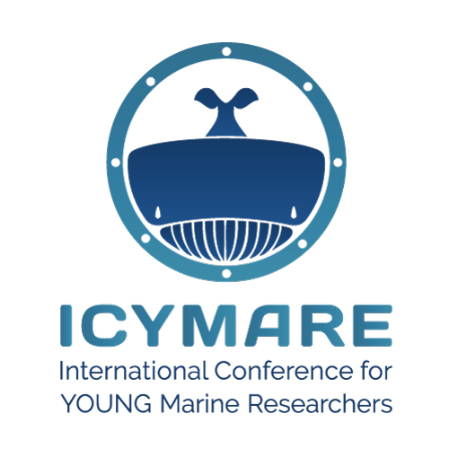 **ICYMARE goes public!**

**Bring your science to the people**

Please fill in this form if you would like to actively participate in the public events connected to ICYMARE 2024 BREMEN.

Please send this form as a Word document (.docx) via email to us (nwv@icymare.com).

**Deadline 15 July 2024.**

*Please enter your name*

first name last name

*Please enter your email address*

example.example@example.com

*Please enter your mobile phone number*

mobile phone number

*Please provide us with your social media handles (“@...” or link) to enable us to tag you*

Twitter: Twitter handle Instagram: Instagram handle

Facebook: Facebook handle LinkedIn: LinkedIn handle

*main affiliation*

main affiliation

*Please provide us with the social media handles of your first affiliation to enable us to tag the institution (preferably “@...”, otherwise also “#...” is possible)*

Twitter: Twitter handle Instagram: Instagram handle

Facebook: Facebook handle LinkedIn: LinkedIn handle

others, e.g. #ICYMAREfamily

**Please summarize your CV in 5 sentences:**

summary of CV

**Please indicate in which event you would like to actively participate:**

**Exploring together: The Power of Citizen Science**

Thursday, 19 September 2024, 7 pm, Haus der Wissenschaft Bremen

**Please summarize your citizen science project in 5 sentences**

summary of the project

**Homepage of or online resources of the project**

link to the project

**Science to the people! ICYMARE at the Marine Science Walk Bremen 2024**

Saturday & Sunday, 21 & 22 September 2024, 10 am - 6 pm

Are you available during both full days? If not, please specify.

**Please summarize your exhibition idea in 5 sentences:**

summary of idea

**Please list the material/infrastructure that you need to realize your exhibition idea:**

material / infrastructure requirements

Please indicate what you can bring and what not. We have limited capacities to organize equipment. There is space around the tent to present bigger equipment. Transportation is organized by yourself. Electricity is available at the tent. Please indicate if you need freshwater (no seawater available).

**Further comments?**

Let us know